**Nslookup(Type A & Type NS)**

**Name:** Muhammad Fahad

**ID:** FA19-BSSE-0014

**Course:** Data Communications and Networks

**Section:** BM

**Teacher:** SYED MEIRAJ Hasan

**Nslookup(Type A & Type NS)**

1. [www.pakistan.gov.pk](http://www.pakistan.gov.pk)

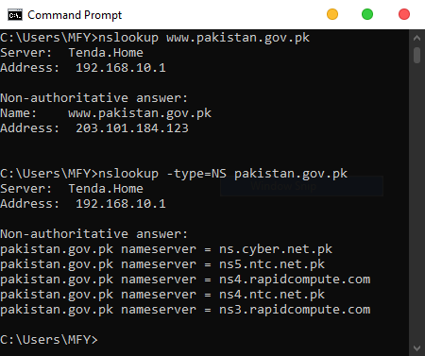

1. [www.nadra.gov.pk](http://www.nadra.gov.pk)

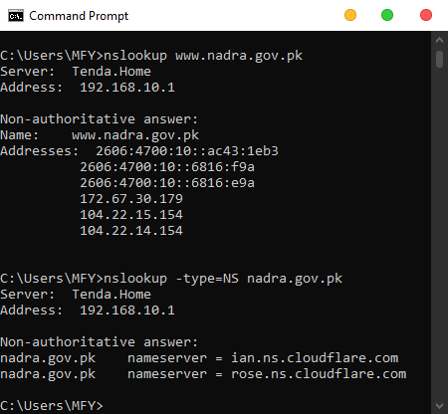

1. [www.pmo.gov.pk](http://www.pmo.gov.pk)

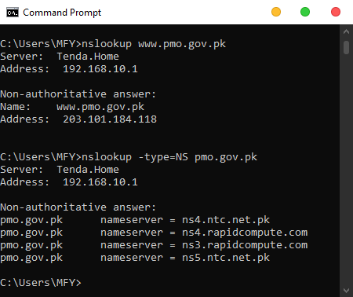

1. [www.uet.edu.pk](http://www.uet.edu.pk)

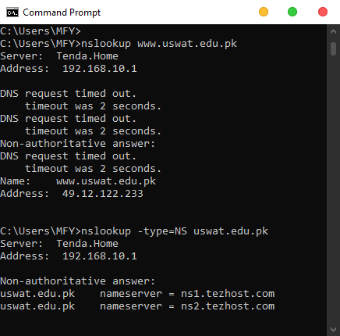

1. [www.uswat.edu.pk](http://www.uswat.edu.pk)
2. [www.kum.edu.pk](http://www.kum.edu.pk)

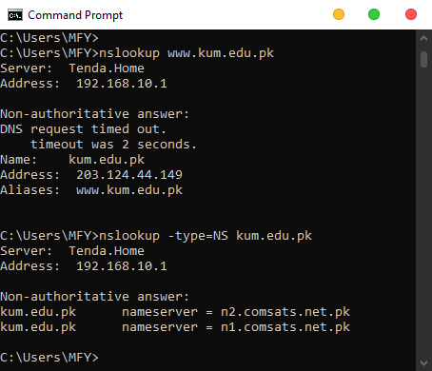

1. [www.microsoft.com](http://www.microsoft.com)

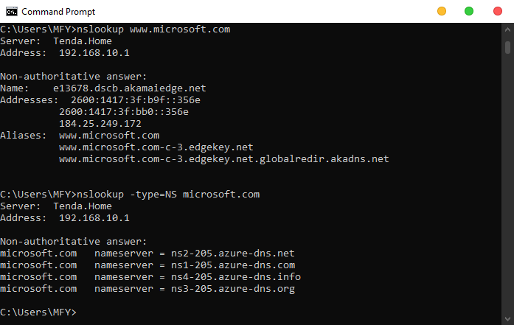

1. [www.ufone.com](http://www.ufone.com)

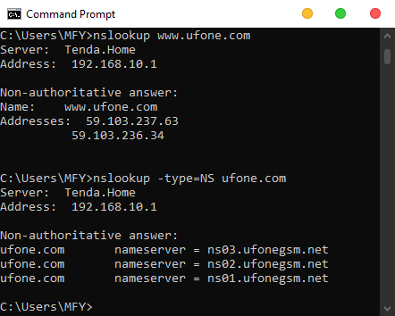

1. [www.jazz.com.pk](http://www.jazz.com.pk)

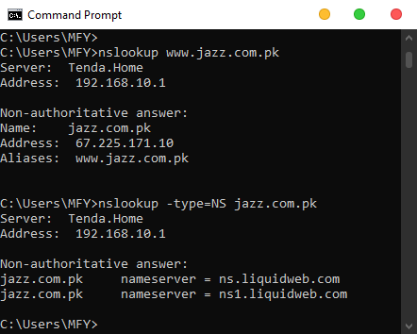

1. [www.telenor.com.pk](http://www.telenor.com.pk)

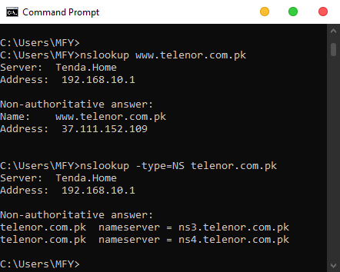

1. [www.jinnah.edu](http://www.jinnah.edu)

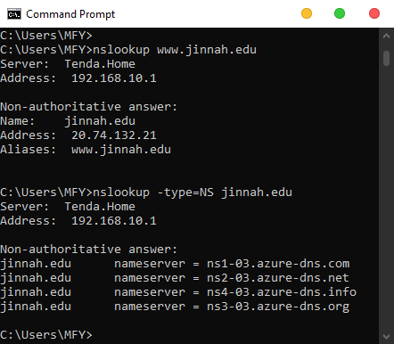

1. [www.nust.edu.pk](http://www.nust.edu.pk)

